
PopUps UI System Tutorial
Current Version: 1.0.0
Last Update: 03/03/2016
Developers: Chrystian Silva / Fraktalia Studios S de RL

Table of Contents
Introduction
Usage
Details
Feedback, Feature Suggestions and Bug Reports

Introduction

The purpose of this subtool of the UI System is to make use of the already implemented functionalities in the UI System and provide a clean way of creating a upper layer of UI where Pop ups can be shown. This pop ups act almost as a screen in the same system with the difference that they have a background and a screen element, both of them are shown on top of the current UIScreen. For that reason it is important that you make yourself familiar with the UI System.

Usage

Now that you are familiar with the UI System we can learn the main differences with this subsystem.
The main difference are the next:
a) There are two Lists of screen controllers, one for PopUps and one for the backgrounds those pop ups use.
b)The Pop ups list can only have background complements. The Pop ups Backgrounds list cannot have any complement. The good point is that all this are completely automatic in the editor.
c) By having this two lists the buttons to create, delete, spawn, despawn are doubled.
Although this is a subsystem of the UI System it is not necessary to have an UIManager in the scene for this to work, but if there is one, then the pop ups will always be on top of the screens in that system.
It is also important to notice that when multiple pop ups are spawned they will be rendered in the spawned order, having the last one on top of all the others along with its backgrounds.
The usage is quite similar to the UISystem:
- Create PopUpsManager.
Drag and drop the PopUpsManager prefab or add the PopUpsManager component to a new or existing Gameobject in the scene.
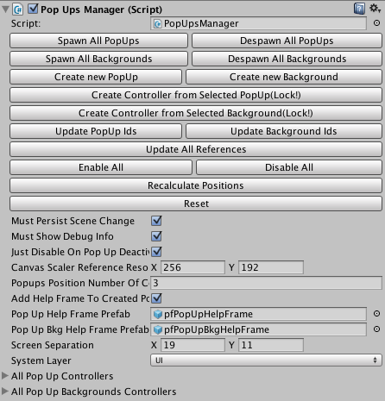
- Set UI System Layer.
It is important that before start working with the system you have setted up the System Layer vaule the full PopUps System will use. This layer will be used along all the cameras involved in the Pop upsUI and every object that belongs to the PopUpsUI should be in that Layer. So go ahead, create and set a new Unity Layer that you feel comfortable using for the Pop upsUI system. If you have already a UIManager you should use the same that it is setted there and if the UIManager is in the scene the Pop ups system will automatically take the value in the UIManager
- Create PopUps and backgrounds.
To create Pop ups or pop up backgrounds you can follow the same steps that in the UIManager but using the next buttons:
+Create New Pop Up
+Create New Background
+Create Controller From Selected Pop Up
+Create Controller From Selected Background
A created from zero UIScreenManager for this subsytem needs to have the “IsPopUp” flag turned on.
- Set an Unique ID.
In order to change the Unique Id of a UIScreenManager can be done in two different ways:
4.1.- Select the UIScreenManager gameObject and change the Unique Screen Id, then press hte “Update Id In Manager” button.
4.2.- Select the PopUpsManager gameObject and open its “All Pop Up Controllers” or “All Pop Up Background Controllers” array. Now search the controller with the current id of your UIScreenManager.
Change the UI Unique Id and press the “Update Pop Up Ids” or “Update Background Ids” button.
- The PopUpsManager functionalities.
The PopUpsManager have several buttons that provide different functionalities and all of them will be explained next:
5.1.- Spawn All Pop Ups or Spawn All Backgrounds: This button will instantiate all the screen objects that have a prefab and aren't already in the scene in the corresponding category, but it will deactivate them all, so you can choose which one to work with.
5.3.- Despawn All Pop Ups or Despawn All Backgrounds: This button will destroy all the screen objects registered that have a prefab assigned in the corresponding category .
5.4.- Create new Pop Up or Create new Bakcground: This button will create a new UIScreenManager with all the elements the PopUpsSystem needs to work with, it will also register the newly created screen in the PopUpsManager to control it in the corresponding category.
5.5.- Create Controller From Selected Pop Up or Create Controller From Selected Background: This button will register an already created UIScreenManager, to use it you must lock the inspector tab first and then select a gameobject with the appropiate components (see step 3). The selected object can be either a prefab or a gameobject in the scene and will be registered in the corresponding category.
5.6.- Update Pop Up Ids or Update Background Ids: This button will update the ids in all the screen objects, prefabs and related screen arrays of every screen registered in the corresponding category.
5.7.- Update All References: This button will search if the current screen object inside a controller have a prefab reference and if they do it will update it in the controller for both categories.
5.8.- Enable All: This button will enable all the in scene pop ups and backgrounds.
5.9.- Disable All: This button will disable all the in scene pop ups and backgrounds.
5.10.- Recalculate Screen Positions: This button will recalculate and reposition every registered pop up and background using the “Screen Position Number Of Columns” and “Screen Separation” values.
It is important to notice that while the screens in the UIManager are positioned from zero to the (+,+) quadrant in a plane, the pop ups are positioned on the (-,+) quadrant, while backgrounds are positioned in the (-,-) quadrant.
5.11.- Reset: This button will reset the PoUpsManager to its initial state removing all the registered UIScreenManagers from it, it will also destroy every registered screen that is in scene.
5.12.- All Pop Up Controllers: This array is used to show, control and edit every UIScreenManager controller that belongs to a Pop Up. Press the “+” button to create a new empty controller to assign the data manually.
5.13.- All Pop Up Background Controllers: This array is used to show, control and edit every UIScreenManager controller that belongs to a Pop Up Background. Press the “+” button to create a new empty controller to assign the data manually.

- UI Screen Controller.
Usually a UI Screen Controller looks different depending if it is a Pop up or a Background they look like this:
Pop Up when you have no Backgrounds:
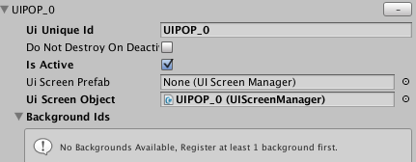
Pop Up when you have Backgrounds that can be associated:
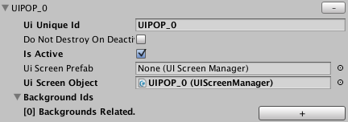
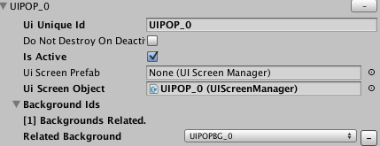
Background look like this:
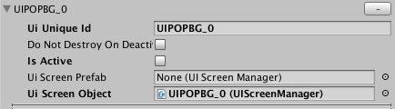
This controllers have some control values that will be explained next:
6.1.- Remove(“-”): This button will remove the controller and the Id of this controller will be automatically removed from complements.
6.2.- UI Unique Id: The value in this field will be used to identify this Popup or background and all the operations related to it.
6.3.- Do Not Destroy On Deactivation: This flag controls at per pop up or background level whether or not it must be destroyed when deactivating. It will only destroy if there is a prefab associated.
6.5.- Is Active: Shows whether this UIScreenManager is active or not.
6.6.- UI Screen Prefab: The reference to the UIScreenManager prefab related to this controller.
6.7.- UI Screen Object: The reference to the UIScreenManager in scene.
6.8.- Background Ids: This list will show all the related background ids that the pop up will use, when the “+” button is pressed it will grow the list and let you choose or remove an available Id. You will not be able to select the same id twice.
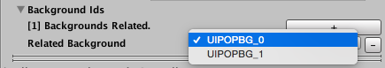
- UI Screen Manager.
This component is exactly the same, but it must have the Is Pop Up flag turned on.
- UI Screen.
This component is exactly the same that in the UI System.
- Switching pop ups from code.
To show a Pop up along with its background:
PopUpsManager.GetInstance().ShowPopUpWithId("PopUpId");
To hide a Pop up along with its background:
PopUpsManager.GetInstance().HidePopUpWithId("PopUpId");
To show a Pop up along with its background and hide every other one that is active:
PopUpsManager.GetInstance().SwitchSolo("PopUpId");
To show/hide all the Pop ups along with its backgrounds:
PopUpsManager.GetInstance().SwitchAllPopUps(true);
PopUpsManager.GetInstance().SwitchAllPopUps(false);
- Update a Pop Up.
To send an update event to the pop ups you can do this:
PopUpsManager.GetInstance().UpdatePopUpById("PopUpId");
PopUpsManager.GetInstance().UpdateAllActivePopUps();
- To Listen to Pop Up Events.
To listen to the different pop up events you can do this:
For general events:
void OnEnable()
{
PopUpsManager.OnPopUpStatusChanged += OnPopUpStatusChanged;
}
void OnDisable()
{
PopUpsManager.OnPopUpStatusChanged -= OnPopUpStatusChanged;
}
void OnPopUpStatusChanged(string popupId,bool enabled)
{
Debug.Log("PopUpStatusChanged ["+popupId+"] to ["+enabled+"]");
}
For pop ups specific events:
void PopUpStatusChanged(bool enabled)
{
if(enabled)
{
//DO SOMETHING AFTER THE POPUP ACTIVATES
}
else
{
//DO SOMETHING WHEN THE POPUP DEACTIVATES
}
}
void PopUpUpdated()
{
//DO SOMETHING WHEN THE POPUP GETS AN UPDATE EVENT
}
void OnEnable()
{
PopUpsManager manager = PopUpsManager.GetInstance(); manager.RegisterToChangeEventForPopUpWithId("MyInterestedPopUpID",PopUpStatusChanged);
manager.RegisterToUpdateEventForPopUpWithId("MyInterestedPopUpID",PopUpUpdated);
}
void OnDisable()
{
PopUpsManager manager = PopUpsManager.GetInstance();
manager.UnregisterToChangeEventForPopUpWithId("MyInterestedPopUpID",PopUpStatusChanged);
manager.UnregisterToUpdateEventForPopUpWithId("MyInterestedPopUpID",PopUpUpdated);
}
- Access Specific UIScreen class in a pop up from outside:
You can access the UIScreen class in an scpecific pop up by using the next code, it is important to notice that in the example the class reference we are getting must inherit the UIScreen class:
PopUpTestScreen popup = PopUpsManager.GetInstance().GetUIScreenForId<PopUpTestScreen>("PopUpWithComponentId");
if(popup != null)
{
popup.DoSomething();
}
- Recommendation.
The system works independently of which pop ups are in the scene and if they are active when you press the editors Play button, but if you are making a build to test in your platform we recommend to despawn all the pop ups.
When the UIManager Awakes it will switch off all the pop ups registered.

Details

Below you can find more information about fields and methods of the class involved in this system.
PopUpsManager Extra Fields and Methods
public static PopUpStatusChangedEventHandler OnPopUpStatusChanged
Event raised when a pop up has change from active to deactive, it is call for every pop up changed.
public float _minCameraDepth
The camera depth that will be used as a min value for the pop up sorting process, If there are screens from the UIManager with a camera depth larger it will take them in to account.
public bool _justDisableOnScreenDeactivation
If true all the pop ups will remain in the scene after deactivation, otherwise if there is a prefab related to this pop ups it will be destroyed.
public List<UIScreenController> _allPopUpControllers
The list holding all the pop ups controllers this manager use.
public List<UIScreenController> _allPopUpBackgroundControllers
The list holding all the pop up backgrounds controllers this manager use.
public Vector2 _canvasScalerReferenceResolution
The Canvas Scaler component value when the pop ups are created with the PopUpsManager. For more info on how the canvas scaler works visit: Unity Documentation
public int _popupsPositionNumberOfColumns
This number is used to change the pop up positions in the scene.
public bool _addHelpFrameToCreatedPopUps
If true it will add the _ popUpHelpFramePrefab or the popUpBkgHelpFramePrefab prefab in the pop ups or backgrounds created with the PopUpsManager.
public GameObject _popUpHelpFramePrefab
The prefab used when creating new pop ups with the PopUpsManager.
public GameObject _popUpBkgHelpFramePrefab
The prefab used when creating new backgrounds with the PopUpsManager.
public Vector2 _screenSeparation
The offset between pop ups or backgrounds used to set their positions.
public LayerMask _systemLayer
The layer that the PopUpsManager will use on all the pop ups and backgrounds created with it. It is recommended to use an specific layer for all the UI system and if the UIManager is present then it will use the layer setted in that component.
public static float GetBiggestCameraDepth()
Finds the biggest Camera Depth used by the pop ups managed by this system.
public void ShowPopUpWithId(string popUpId)
This switch on the pop up with the id passed and its backgrounds.
public void HidePopUpWithId(string popUpId)
This will switch off the pop up with the id passed.
public void SwitchById(string screenId)
This will switch off the pop up or the background with the id passed alone (without its complements).
public void SwitchSolo(string screenId)
This will switch on the pop up with the id passed with its backgrounds and switch off every other active pop up.
public void UpdatePopUpById(string popUpId)
This sends an event update event to the pop up with the passed id.
public void SwitchAllPopUps(bool enable)
This switches on or off all the pop ups and its backgrounds.
public void UpdateAllActivePopUps()
This send the update event to all the active pop ups.
public UIScreen GetUIScreenPopUpForId(string popUpId)
This will return the UIScreen component if any in the pop up with the passed id.
public T GetUIScreenPopUpForId<T>(string popUpId) where T : UIScreen
This will return the T component in the pop up with the passed id, if it have one.
public Vector3 GetPopUpPosition(string popUpId)
This return the position of a pop up with the passed id, or a new one if no id is founded.
public Vector3 GetPopUpBkgPosition(string popUpBkgId)
This return the position of a background with the passed id, or a new one if no id is founded.
public void ResetAllPositions()
This recalculates the positions of all the registered pop ups and backgrounds.
public void RegisterToChangeEventForPopUpWithId(string screenId,UIScreenController.ScreenChangedEventHandler listener)
This function register the listener passed in the OnScreenChange event with the id passed.
public void UnregisterToChangeEventForPopUpWithId(string screenId,UIScreenController.ScreenChangedEventHandler listener)
This function unregister the listener passed in the OnScreenChange event with the id passed.
public void RegisterToUpdateEventForPopUpWithId(string screenId,UIScreenController.ScreenUpdatedEventHandler listener)
This function register the listener passed in the OnScreenUpdate event with the id passed.
public void UnregisterToUpdateEventForPopUpWithId(string screenId,UIScreenController.ScreenUpdatedEventHandler listener)
This function register the listener passed in the OnScreenUpdate event with the id passed.
public bool IsPopUpActive(string popUpId)
Returns whether the pop up with the passed id is active or not.

*For a complete example of how the UI Pop Up System works, please check the provided Test scene.

Feedback, Feature Suggestions and Bug Reports

Send by email: contact@fraktaliastudios.com. Write PopUps System in the subject. For bugs please attach images, logs and code examples.

